**AWS EFS Mount With EC2**

**WITH NFS**

goto aws ec2 services

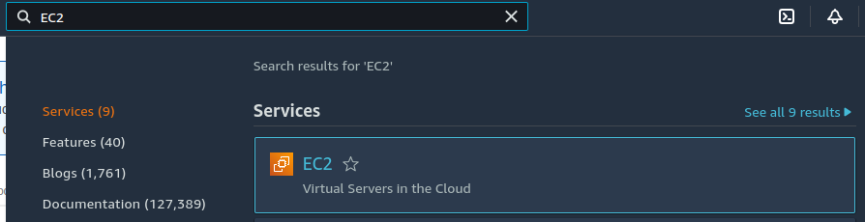

launch services with NFS Securty port

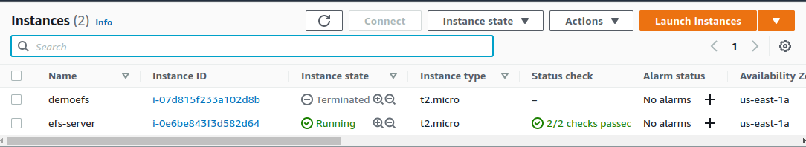

connect



open terminal

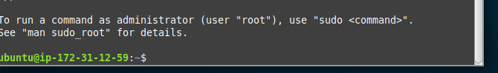

sudo apt update

**Open AWS EFS services**

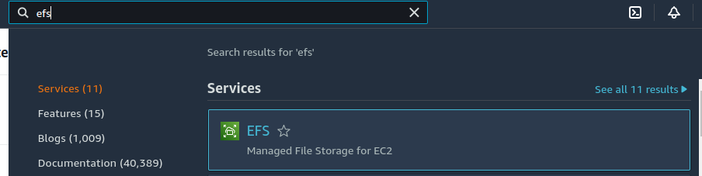

**click on create file system**

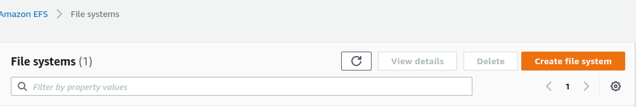

**name than goto costomize**

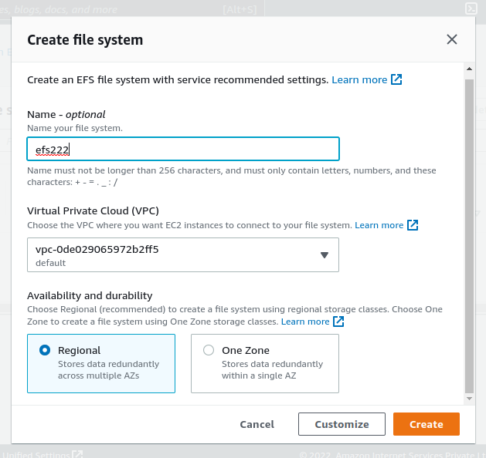

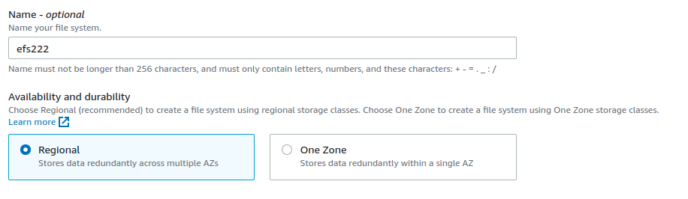

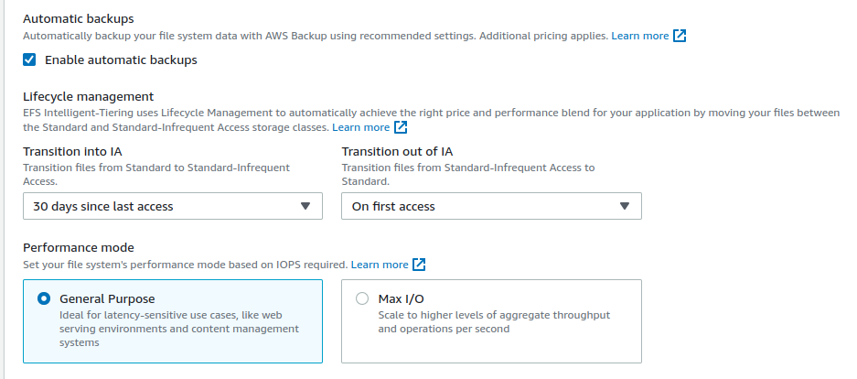

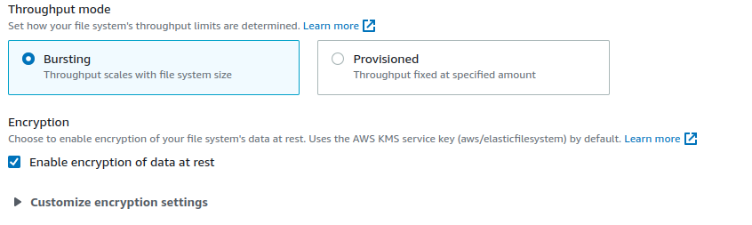

**choose your VPC avalibily zone Security Group**

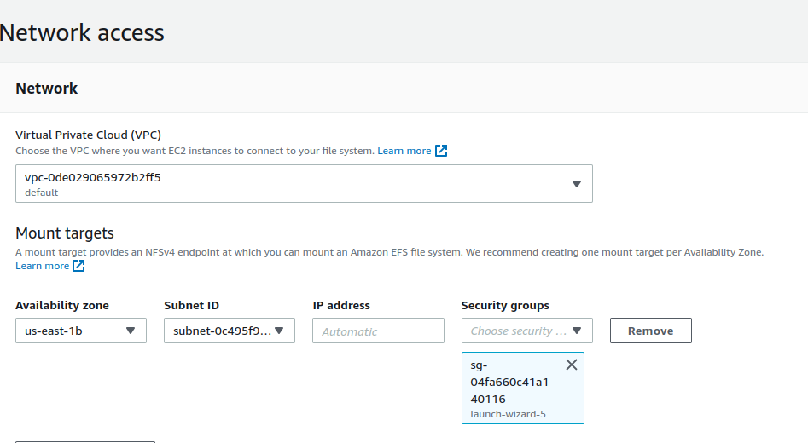

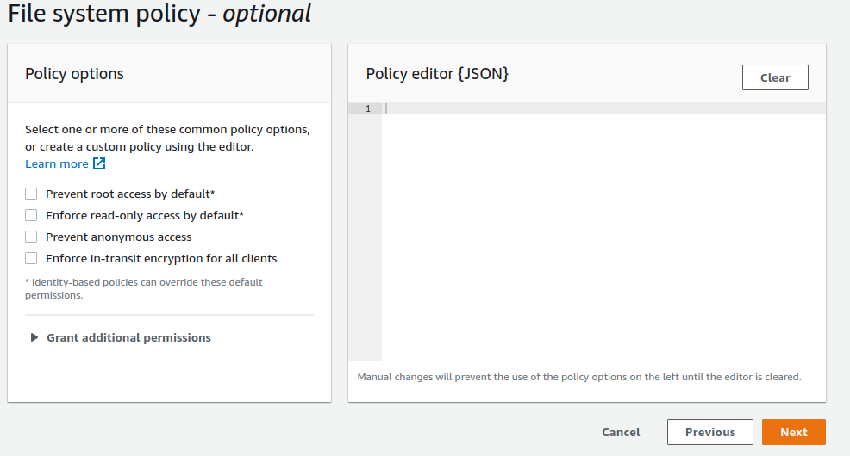

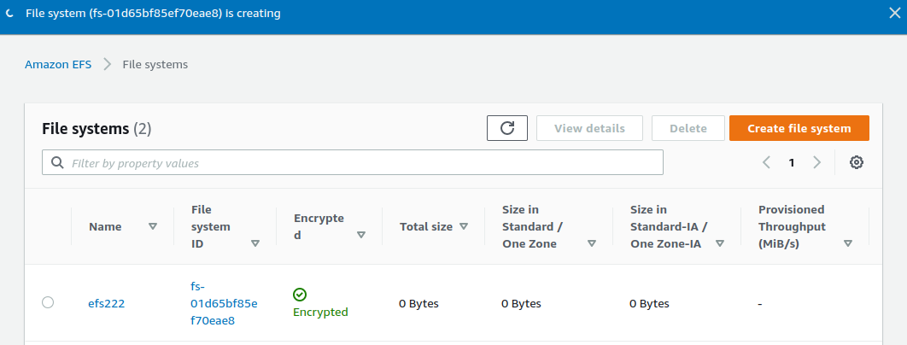

**Go to Your EC2 instance Terminal**

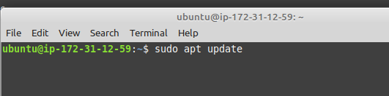

**run following command**

**sudo apt update**

**sudo apt-get -y install nfs-common**

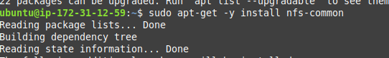

**mkdir nfs**

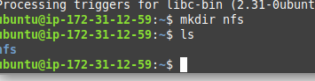

**copy this command**

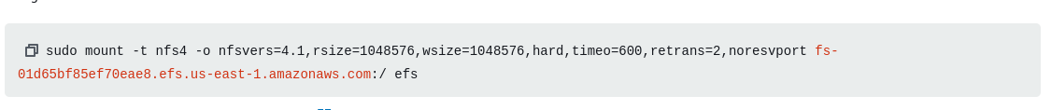

**change path nfs**



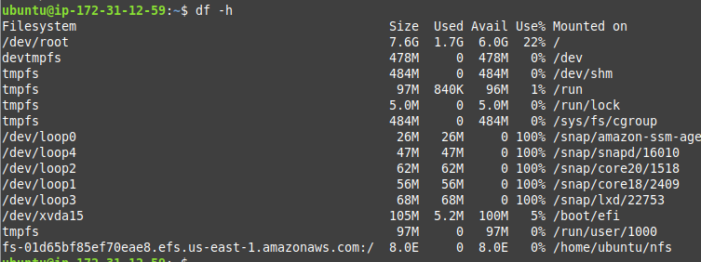

**Permanently mount with efs**

**sudo nano */ etc / fstab***





